Practice Assignment _Nadir Hussain _213193

# 1.

# 2.

# 3.

# 4.

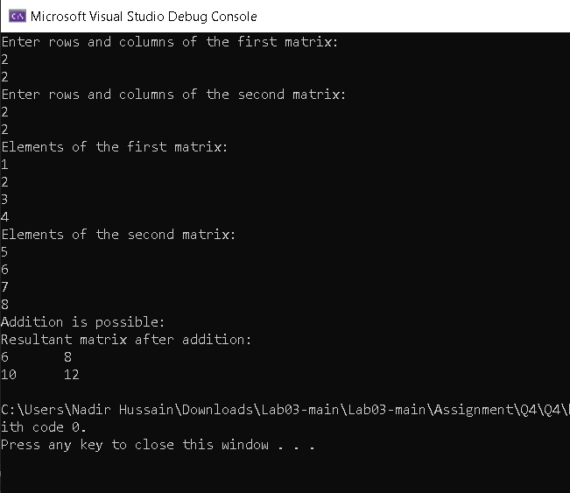

# 5.

# 6.

# 7.

# 8.

# 9.

# 10.

# 11.

# 12.

# 13.

# 14.

# 15.

# 16.

# 17.

# 18.

# 19.

# 20.

# 21.

# 22.

# 23.

# 24.

